Project Spam Email Detector

Problem Statement:

Email spam wastes time, increases cybersecurity risks, and can expose users to phishing attacks and malware. Traditional rule-based spam filters struggle to keep up with evolving spam techniques.
This following project and report will investigate whether the use of machine learning can automatically classify email as spam or legitimate based on the text content and format.

Aims:
The aim of this project is to create a product that can efficiently detect if an email is spam or legitimate based on the text content that is also easy to use.

Targets:
One of my targets is to make people more vigilant and wary when it comes to coming across spam emails and having the intuition to spot a legitimate email from a fake one.
Another one of my targets is to maintain a 80% success rate in terms of successfully detecting if the text from an email is actually spam or not.

Objectives:
- Build an easy-to-use product with python, HTML, and various Machine learning features and techniques
- Close the barrier in terms of people acknowledging the difference between a legitimate and a spam email.
- Use a dataset to learn text classification so that it can be used for my model to ensure that when detecting the text content that it is accurate.
- Improve my skills within machine learning and Python in general
- Prepare myself for my Masters course where I will have to do an entirely different project that could potentially be ML/AI related.

Resources:
To solve the problem outlined early in the problem statement section. The following resources that I will be implementing into this project in order to achieve my goal includes:
- Python
- HTML
- Text Processing
- Feature Extraction
- TF-IDF
- Naïve Bayes
- Logistic Regression
- Random Forest
- Model Evaluation
- Flask
- Git
What is spam?
Spam is the use of electronic messaging system to send bulk messages that are unsolicited. This can be in the form of SMS messages, and emails.

How global email traffic is dominated by spam emails;
Spam accounted for 47.27% of global email traffic in 2024, which was an increase by 1.27% from the previous year. This shows that even with the counter-measures put in place to help decrease spam emails is not productive as they have become more and more prominent within email traffic. There are a variety of categories that can be classed as spam emails. This includes phishing & malicious content, commercial spam, scams and hoaxes, tech support scams and many more.

Demographic that is affected the most:
It is reported that the most targeted sector in spam emails are professional services (18%) and shortly followed by manufacturing and retail/wholesale with 18% and 9% respectively. Delivery services were the most common subject of spam messages with over 1.1 billion scam texts relating to this topic. This is unsurprising as a vast majority of people uses these delivery services to have the items be delivered so the use of creating identical messages with the same format and structure that these various delivery services use can easily deceive people into entering their personal information and therefore have it taken and be used maliciously.
The demographic that receives the most spam messages/emails/calls are people aged 65 and over, while 18-34 year olds receive the lowest. There is a direct correlation with this as it shows that elderly people are not entirely “internet savvy” and are more prone to being deceived into clicking malicious links and having their personal information seized. The reason for this is that they have not be trained and taught extensively in how to prevent this and take action plus the era that they were brought into were not this advanced when it comes to technology, which leaves them to learn about this as they got older. Whereas with younger people, we were taught how to deal with spam emails, and malicious attacks so we would not be deceived when receiving one.
This shows that with the product I will make, I have to be able to make it user-friendly for all demographics to be able to bridge that gap of learning spam-based literacy so that it can prevent further attacks.

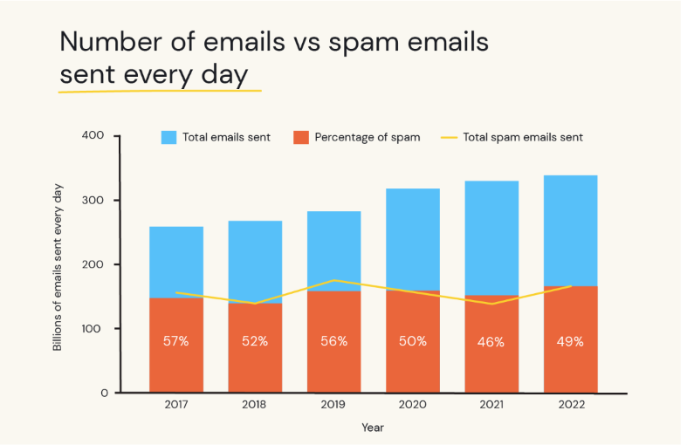
Figure 1 containing number of emails vs spam emails sent every day

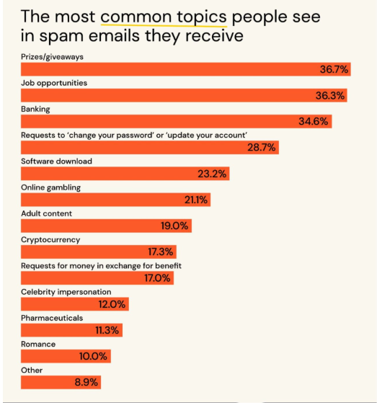
Figure 2 the most common topics people see in spam emails they receive

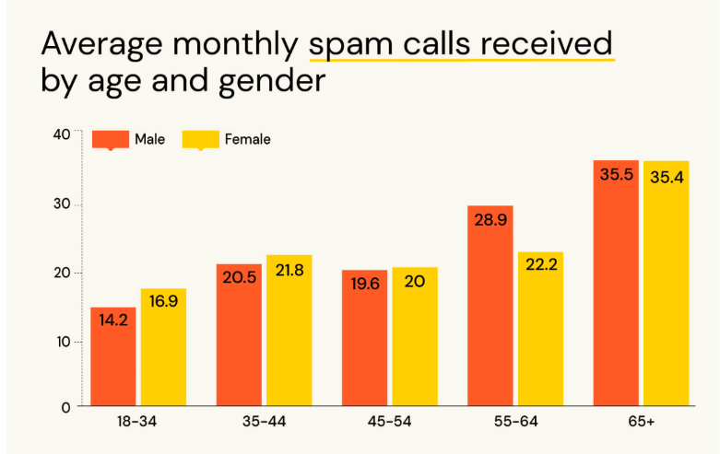
Figure 3 Average monthly spam call received by age and gender

Obtaining and loading the dataset:
Next, I am going to obtain and load a dataset from Kaggle that contains various Spam and Ham (Ham meaning legitimate emails) to analyse it and to learn its text classification. This will help the accuracy of the detector to ensure it is detector the right content as spam.
The dataset I used: https://www.kaggle.com/datasets/ashfakyeafi/spam-email-classification
I then proceeded to load the dataset into python using the kagglehub library and loading it as a csv so I can view it on excel and manipulate to for analysis.
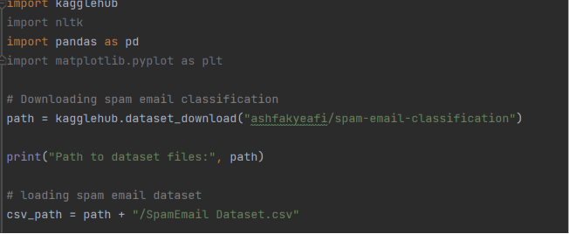
Figure 4 loading spam email dataset into my python file
Count of “spam” & “ham” emails:
Next, I wanted to explore the various features that this dataset has such as the count of how many email are spam and ham. In this case there are 4825 “ham” legitimate emails and 747 spam emails within the dataset.
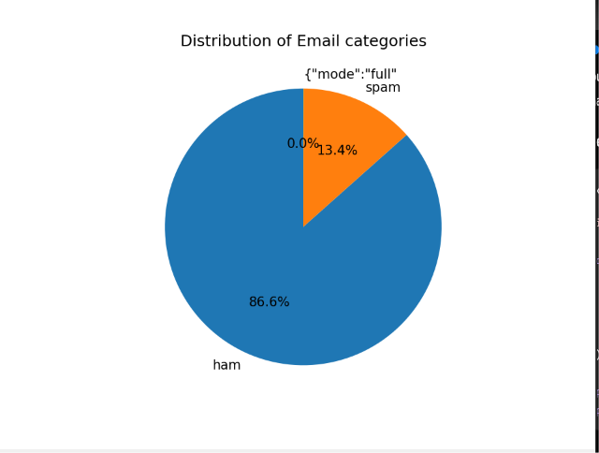
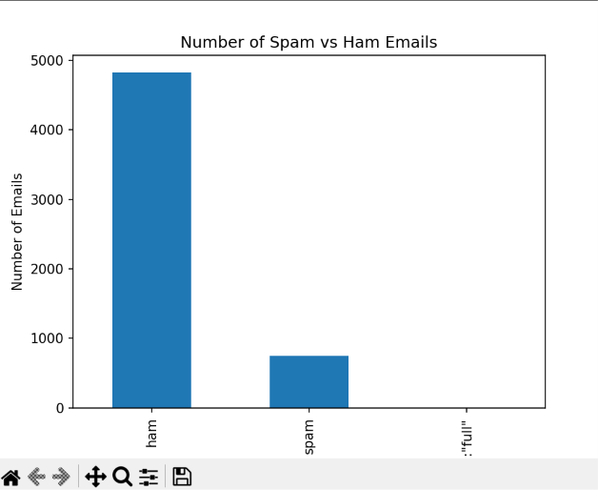
Figure 7 Pie chart showcasing the distribution of email types
Figure 5 Bar chart showcasing the number of spam and ham emails

Structure of Dataset:
In terms of the structure of the dataset there are two columns, with one column being the category so if the message is either “ham” or “spam” and the second column is the Message column. This column contains the text content of the ham or spam message.
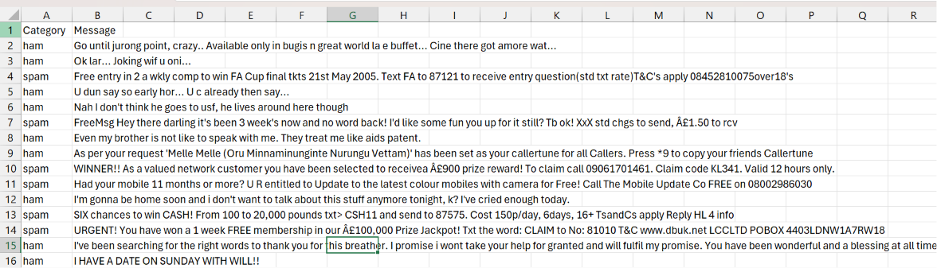
Figure 8 structure of the spam email dataset
Calculating average email length:
When it comes to calculating the average length of a spam or ham email, it shows that spam emails has an average email length of 137.9 with length being used to measure that amount of characters within an email. For ham emails, it has an average character length of 71.4 characters. This shows that spam email usually include more characters in this specific dataset. It also shows us that when detecting if an email is spam or legitimate, taking note of the amount of characters used can give us an indication if such email is real or not. I calculated this on Python using the pandas library to make a new column within the dataset to display this.

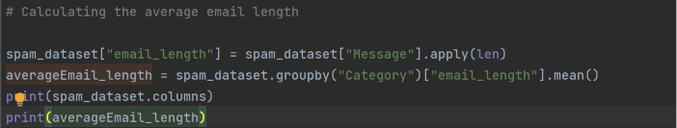
Figure 9 Python code used to calculate average email length
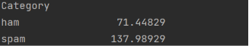
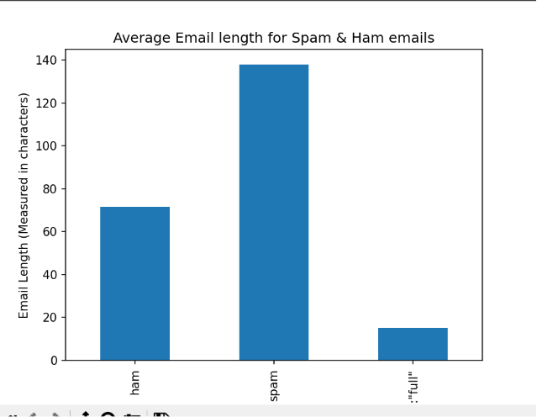
Figure 11 python calculating average length output
Figure 10 bar chart representing average email length

Most frequently used Spam and Ham words:
Next I am going to find out the most frequently used words used in both Spam and Ham emails. This part of the data analysis will help me understand what makes a spam email differentiate from a legitimate one. It will also help me understand what are the common words that can help contribute to the detector to allow it to be more accurate and efficient when detecting text content from emails.
During this section there was an issue I had to overcome. When calculating the most frequent words it was working originally however, the frequent words that were appearing within the chart consisted of words that can be considered to be stop words.
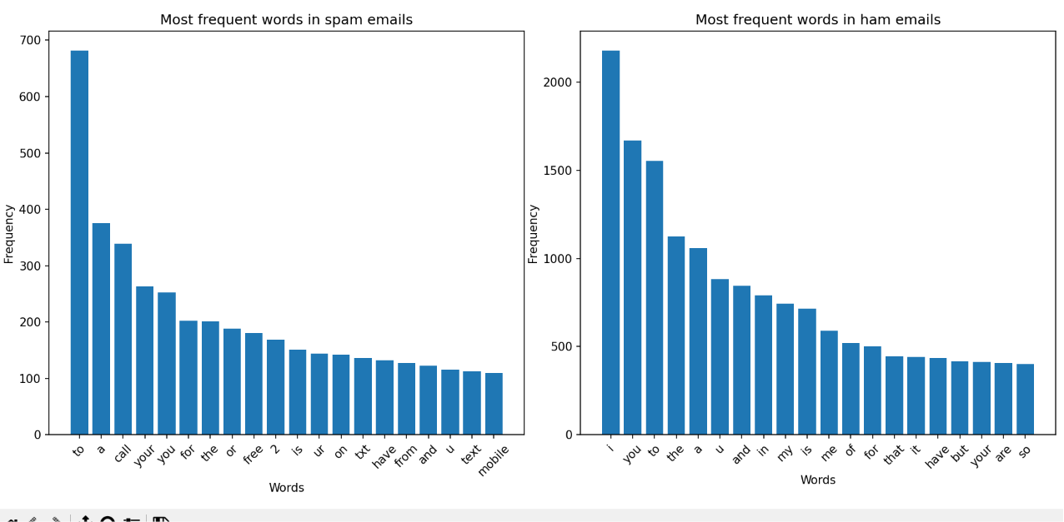
Figure 12 Most frequent words in ham and spam emails before editing to remove stop words
As you can see, the chart has been dominated by words such as "the”, “to”, “and”, “a” etc..
So to fix this, I imported another library called NLTK which is used for building Python programs to work with human language data it provides it users with a variety of tools used to analyse, clean and structure raw human language data. In this specific use case, it is being used to eliminate stop words being involved in the most frequent words chart as it will improve the accuracy and discrepancy of the chart and eventually for the detector being built.

